**Group 7** Carlos Guttormsen

Miska Örmälä

Yuan Qi

**Elaboration Phase Report**

This is group seven’s elaboration phase report for the Introduction to Industrial Informatics course work. In this phase we went over our project’s system vision and refined it in some minor ways. We also designed four different types of diagrams to illustrate our projects

**System vision**

In this project, we are going to develop monitoring and supervisory control system of the whole production line Tampere University of Technology, FAST-Lab. In the process of monitoring the production line, we limit our system vision to a work cell in the factory floor firstly and then extend to the whole production line which should be managed for following months in our project. First, the planning of project should be divided into several parts which could help us to have more clear idea about what we are going to do. In this system vision, there are four sub-branches: project management, business analysis, environment and requirement and design as well.

In the project management, we should know the objectives of the projects and make some assumptions and assign group-members for different sub-tasks. The schedule should be carried out precisely to finish the project on time. This is the initial part but also the most important part in this project as it is the vision of where we should go.

For the business analysis, we need to estimate costs for initializing the project such as the costs for the equipment, salary for the operator and manager, maintenance for robots and conveyor, and profits for the shareholders. We have to consider some issues like our possible costs, limited budget maybe and prospective profits. As the business model is interwoven with requirements, defining a good business model can cover all our needs and requirements of the project.

For the environment model, we should execute our project in the production line of TUT and configuration of work-cell must be well organized to ensure the assembly line running efficiently. The interface of human and machines should be well designed which is helpful when we are controlling the whole system and show the information of the customers

When designing the system which is an iterative task, we create the process outline that shows the feasibility of the project. Of course, we also need to consider the potential risks as well. The principle of design is to make full use of each object and reach our goal best and try to lower the risk. The main costs may come from those aspects such as wage for the crew and waste of scrap and maintenance. Therefore, our priority is to control the budget and fully use our material which lowering our costs.

To better initialize our project, the first thing we should do is that we must get familiar with the surrounding of FASTory and avoid causing some unnecessary mistakes or maybe don’t break any equipment in case of increasing our costs. What’s more, we must know the instructions of some machines like Robots and conveyor and so on. For instance, we need to calibrate the workstation before we do the project. Our target is to master in the manipulation of all machinery and reduce the lifecycle of product.

In creating the system vision, we should focus on the assembly line and the main components of this system such as robot, convey and RTUs. The line consists of two conveyors; main and bypass. The main conveyor is used if the pallet requires service from the work cell. Meanwhile, the bypass is used if the work cell is in busy state to bypass the pallet to the next work cell. The factory line uses SONY SCARA robots for production. Each robot is represented as an RTU in the line. The robots are programed with specific tasks. The FASTory is equipped with INICO S1000 Remote Terminal Units (RTUs). INICO S1000 is a programmable RTU device which offers process control capabilities and all the data will be selected and transferred to here for final analysis and decision.

When running the assemble line in, the suitable components needs to be found respectively. For instance, when we are running the conveyor, which speed is the best for transport of pallet and would not cause congestion on the line. The type and shape of the pallet is maximally flexible for all three products. Those doubts and question must be unveiled when executing the system and get the helpful data for project.

Providing all this architecture (SOA) is impossible without implementing a decent infrastructure for optimization, positioning using sensors and safety switches, resources for maintenance and staff for controlling the whole process (including quality control of the product going out from the manufacturing cell).

To fulfill the task of monitoring we should collect all the data and decide what data to use for monitoring the work cell. For instance, we use INICO S1000 to communicate through web services. It transfers all the data to a web server which can be accessed and processed on the WebStorm, so the needed information is derived for monitoring the work cell. In our case we assume that the user has access to the web site for monitoring is the manager and s/he decides upon receiving the data. Also, we assume the product we mean to monitor in our working cell is a frame of a cell phone that comes in 3 different types of models. We need to closely monitor and assign operators for accomplishing this goal.

**Diagrams**

These following diagrams are designed to demonstrate our project’s setting conditions, different users and business requisites. It is good to take into account, that these diagrams serve as bare directional tools in our project work currently. Each diagram is presented as a picture and followed by a short description to explain its purpose.

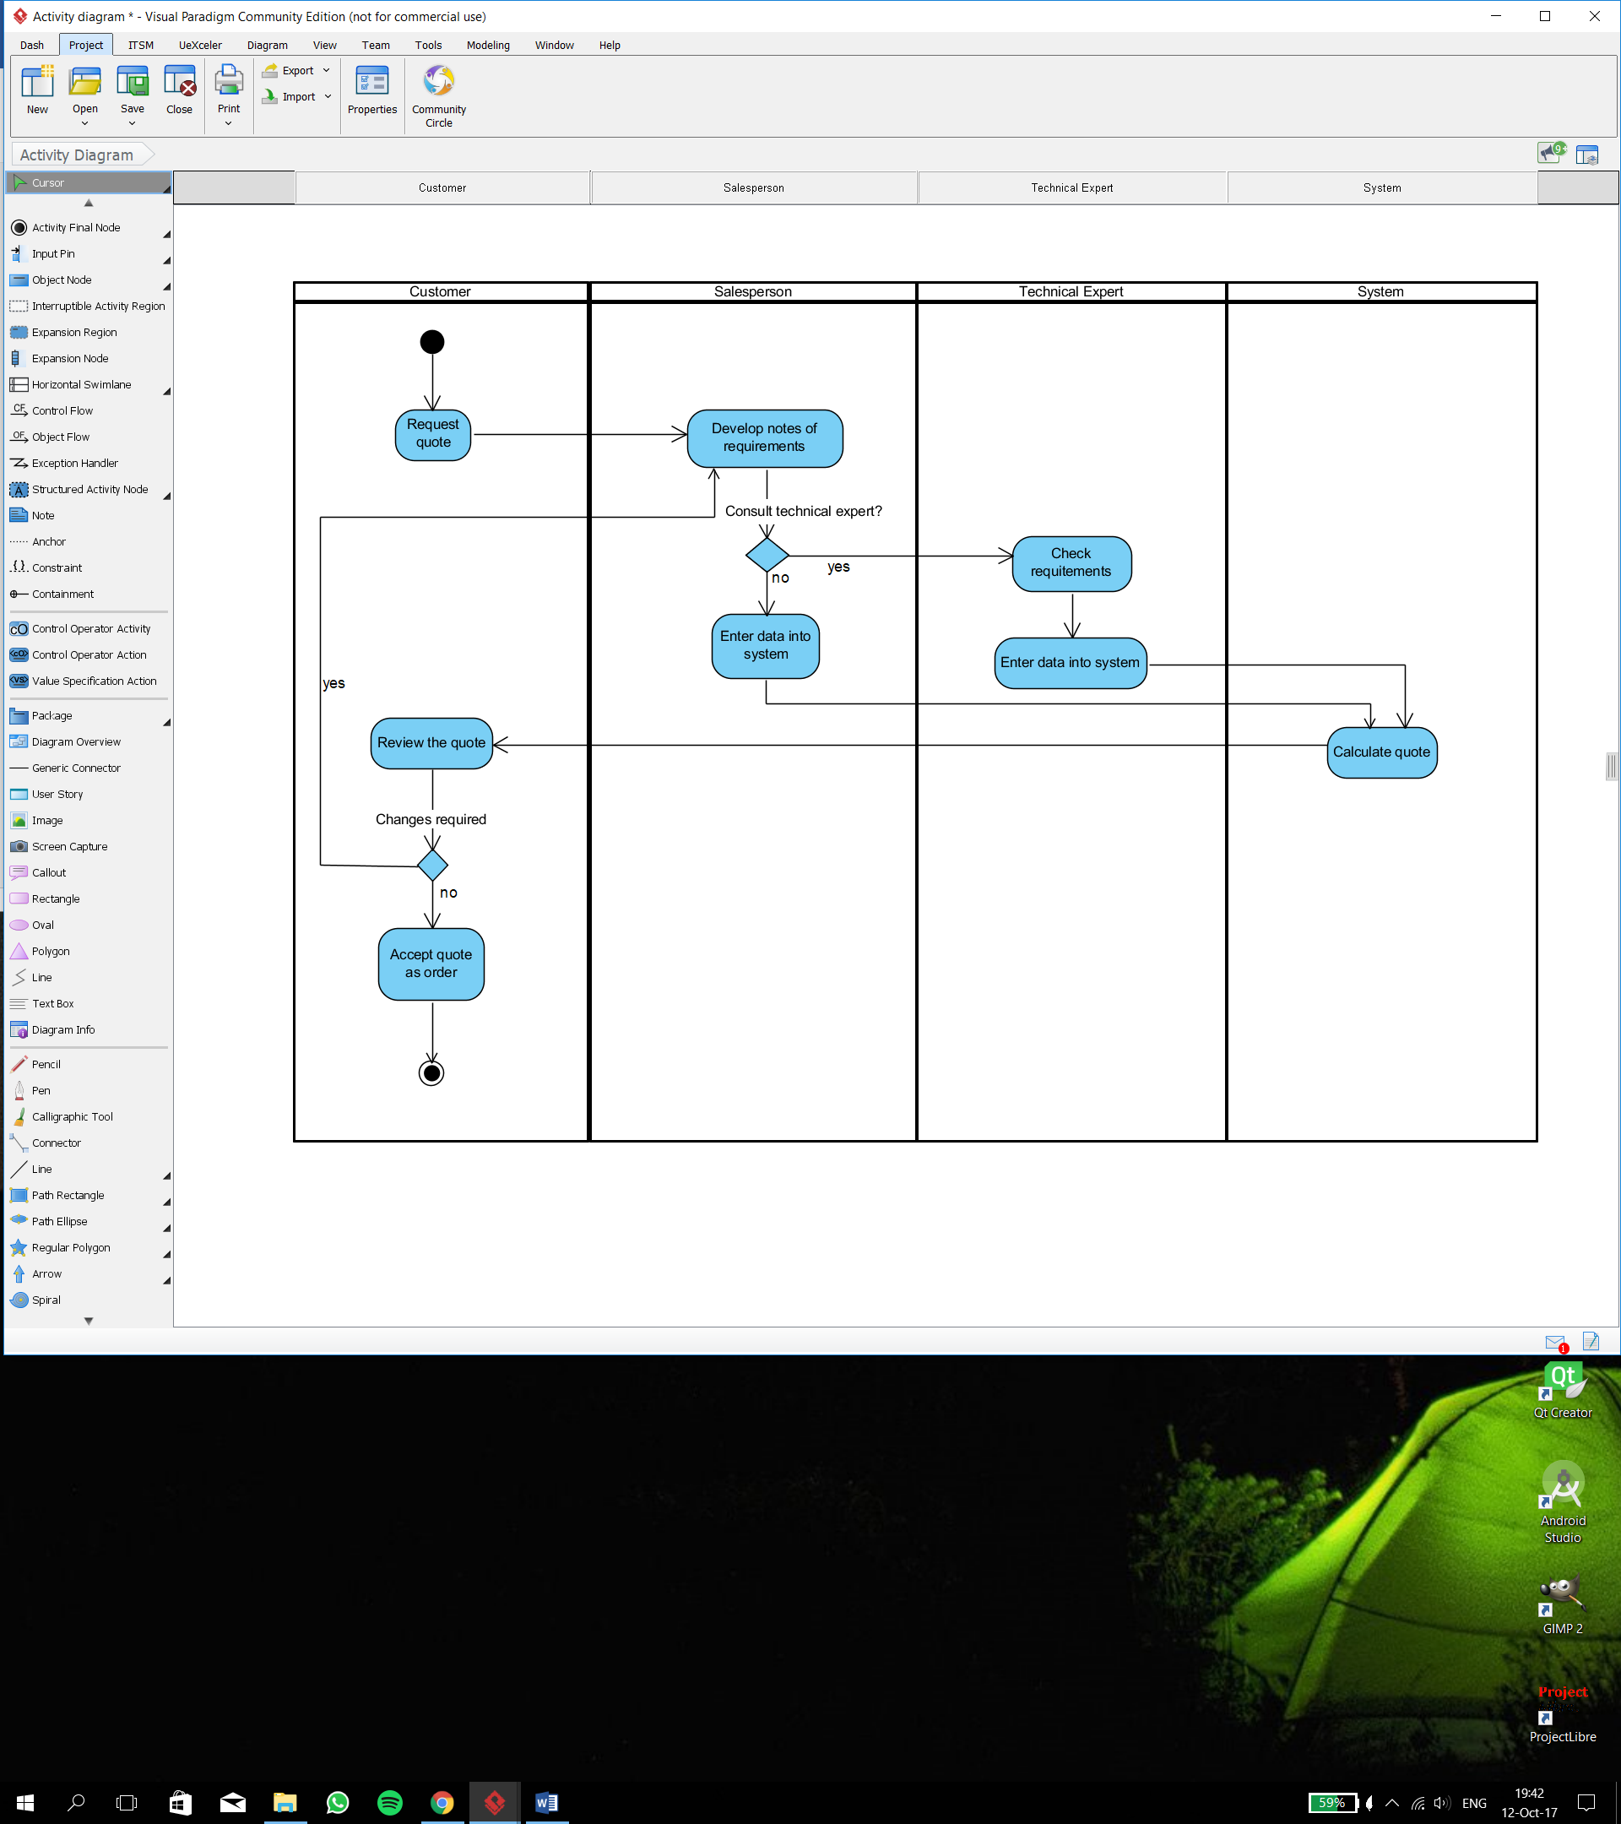

**Picture 1**. Activity Diagram

In picture 1 we have defined our project’s activity diagram which documents the workflows of our business process and flow of activities for use case scenarios and serves as a basis to our project’s sequence diagram.

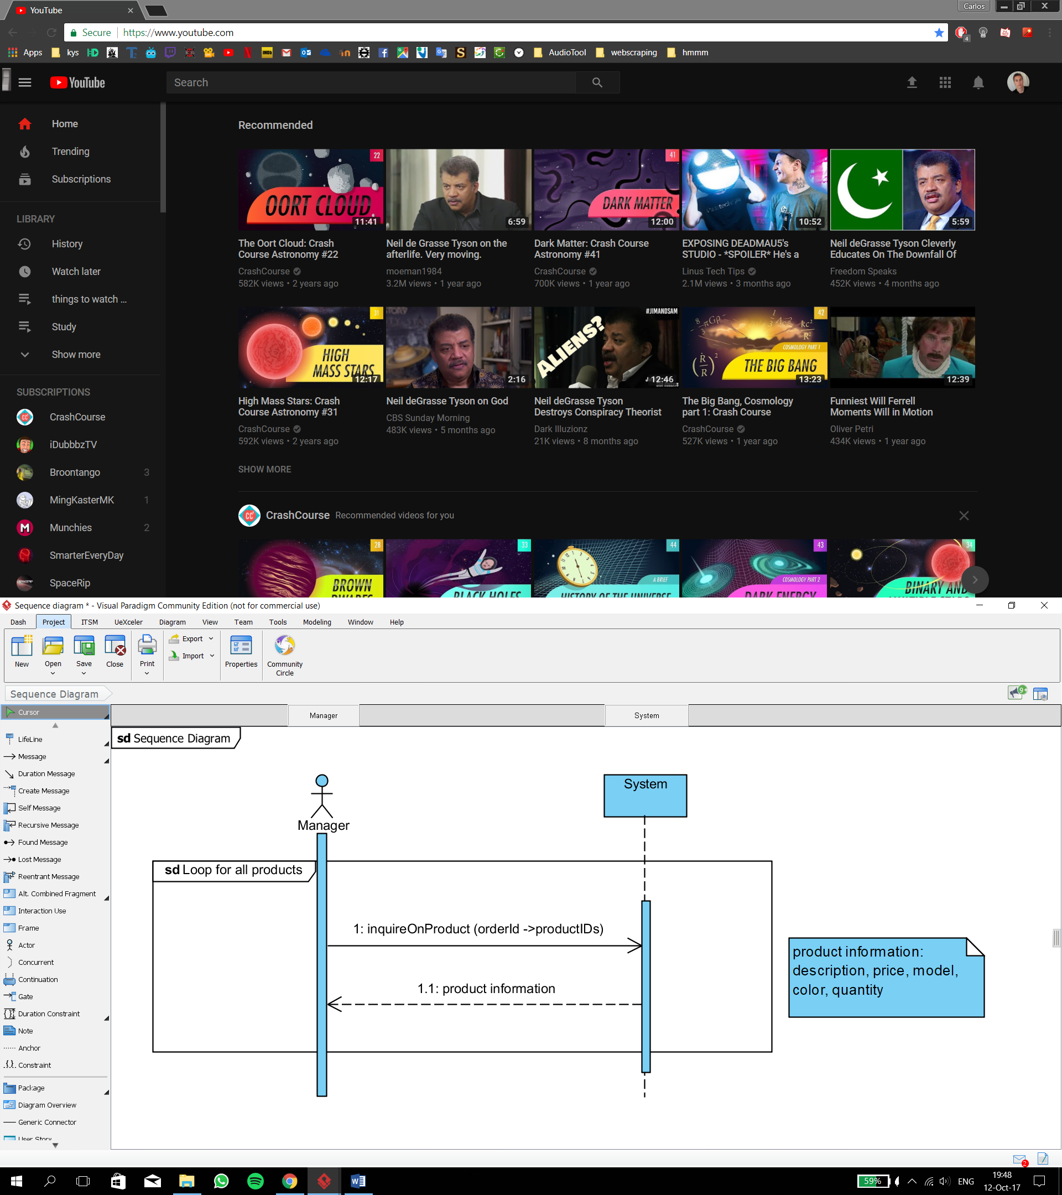

**Picture 2**. Sequence Diagram

Picture 2 shows our system sequence diagram which defines in which sequences of inputs and outputs each order is placed into the system. Only with all the necessary pieces of product information an order can be set to be carried out by our production line to finally become a finished order.

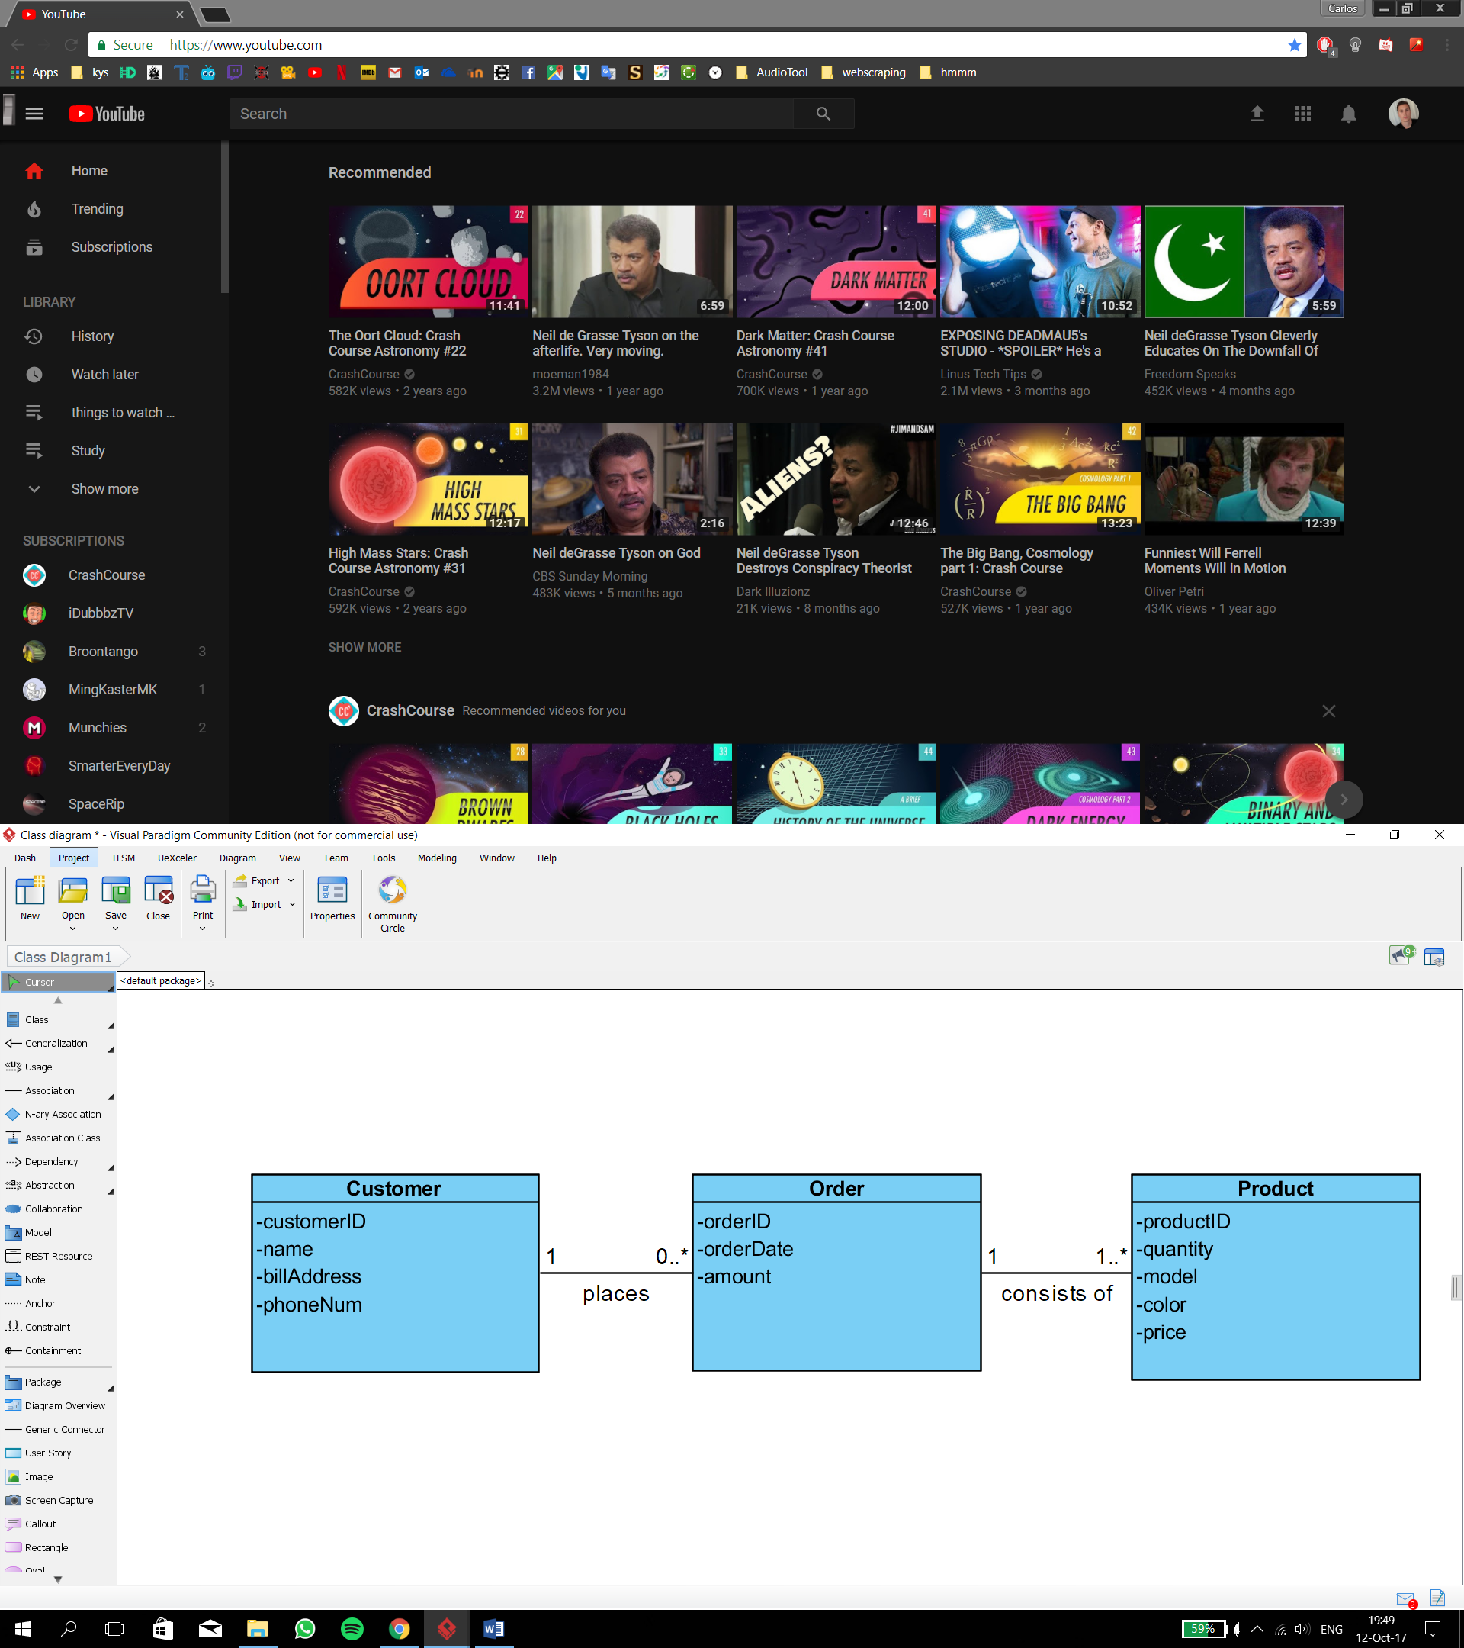

**Picture 3**. Class Diagram

Our project’s class diagram is represented in picture 3. It identifies our business’s process in the real world and determines the structure of the programmed classes and their requirements.

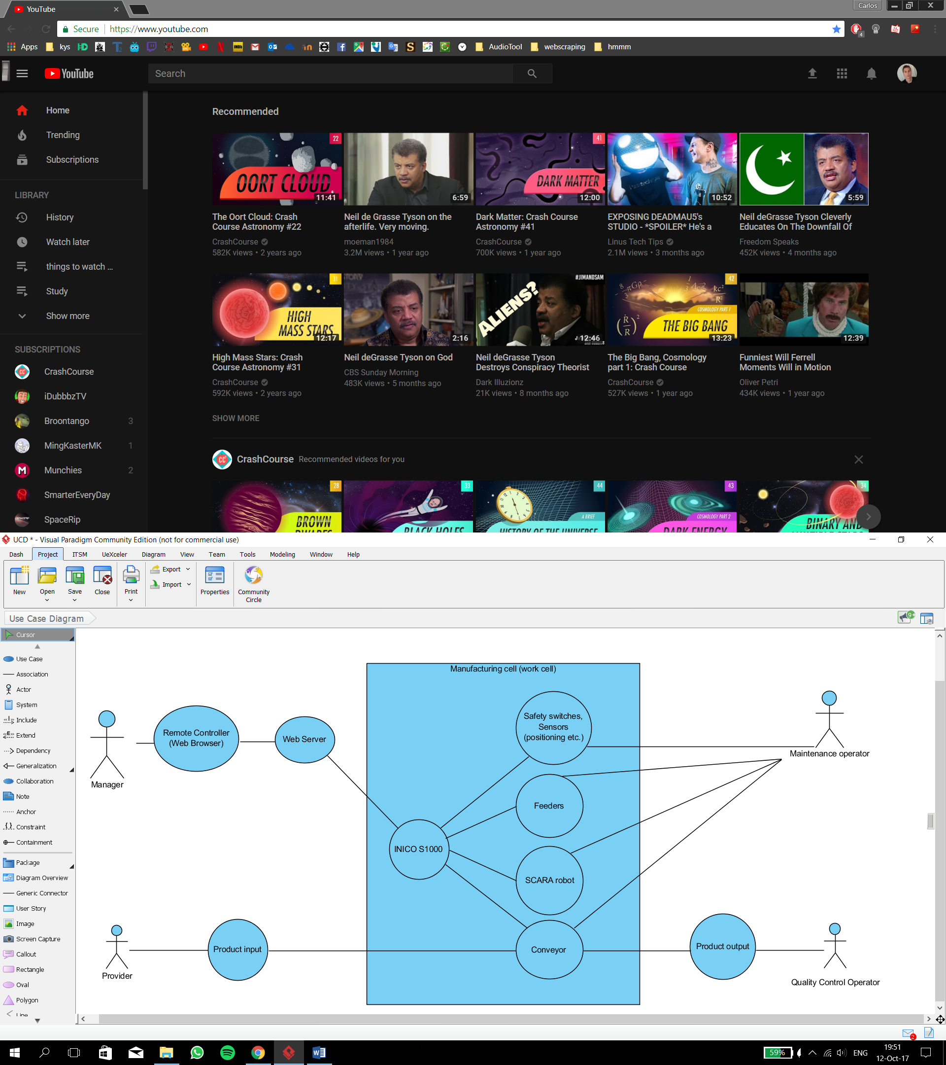

**Picture 4**. Use case Diagram

Finally, our project’s use-case diagram is illustrated in picture 4. It shows the activities the system carries out and the entry points into the modeling process. It is the representation of all the users’ interaction with the system which shows the relationship between each user and the varying use cases in which the user is involved.